Vincent Van Gogh
Who is the real Van Gogh? How is the real Van Gogh different from his perception of himself and/or others’ perception of him? Cite the evidence that most strongly supports your analysis.

 | Information given in the text | Inferences based on the information | Direct Quotes to support inference
Starry Night Painting

Artist:

Year:

“Vincent” Song

Musician:
“The Starry Night” Poem

Author:

Van Gogh: In his own words Video

Author:
Vincent Van Gogh
Who is the real Van Gogh? How is the real Van Gogh different from his perception of himself and/or others’ perception of him? Cite the evidence that most strongly supports your analysis.

 | Information given in the text | Inferences based on the information | Direct Quotes to support inference
Bi-polar Article

Author:

Letter from Vincent Van Gogh to Theo Van Gogh

Author:

“Lane of Poplars” Painting

Artist:

Year:

“Bedroom in Arles” Painting

Artist:

Year:
http://www.bing.com/images/search?q=lane+of+poplars+at+sunset+van+gogh&FORM=HDRSC2#view=detail&id=0055A35590A8962C3751343145FCA67C7E9F7467&selectedIndex=4
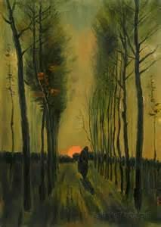
1884

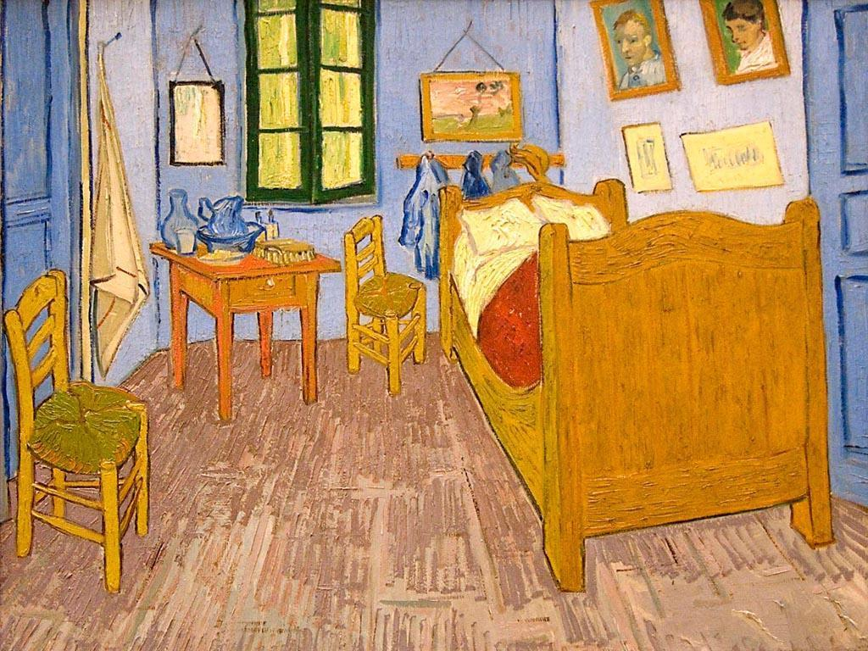
1888
http://www.bing.com/images/search?q=bedroom+in+arles+by+van+gogh&qs=AS&sk=IM1AS2&FORM=QBIR&pq=bedroom%20in%20arles&sc=4-16&sp=4&qs=AS&sk=IM1AS2&id=BBB006EC558A248D95757ED4FECADB526FF741E0&selectedIndex=0#view=detail&id=BBB006EC558A248D95757ED4FECADB526FF741E0&selectedIndex=0

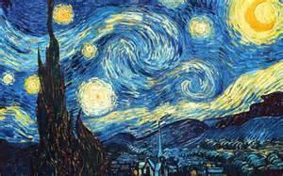
1889
http://www.bing.com/images/search?q=starry+night&qs=n&form=QBIR&pq=starry+night&sc=8-10&sp=-1&sk=#view=detail&id=5ECFC7F3A77E6E9211F746D235C2800FAB4466BA&selectedIndex=1

Vincent Van Gogh
Who is the real Van Gogh? How is the real Van Gogh different from his perception of himself and/or others’ perception of him? Cite the evidence that most strongly supports your analysis.

Through your research, you should be able to answer the above questions. Instead of answering the questions above, create your OWN question to answer. Use the information gathered from the various texts, along with your inferences, to create a question. You are working backward. You have the answer; find the question! ☺

What question can you answer based on your research? ________________________________________________________________

________________________________________________________________________________________________________________________
Now answer! Each box requires one complete sentence.
Claim (thesis): (re-word your question and answer)

Proof 1: | Proof 2:
Proof 3: | Proof 4:

Inference: (based on all the proof gathered)

Conclusion: (explain why your thesis is accurate)

Vincent Van Gogh-merit
Who is the real Van Gogh? How is the real Van Gogh different from his perception of himself and/or others’ perception of him? Cite the evidence that most strongly supports your analysis.

Through your research, you should be able to answer the above questions. Instead of answering the questions above, create your OWN question to answer. Use the information gathered from the various texts, along with your inferences, to create a question. You are working backward. You have the answer; find the question! ☺

What question can you answer based on your research? ________________________________________________________________

________________________________________________________________________________________________________________________
Now answer! Each box requires one complete sentence.
Claim (thesis): (re-word your question and answer)

Proof 1: | Proof 2:

Inference: (based on all the proof gathered)

Conclusion: (explain why your claim is accurate)

Vincent Van Gogh-merit
Who is the real Van Gogh? How is the real Van Gogh different from his perception of himself and/or others’ perception of him? Cite the evidence that most strongly supports your analysis.

 | Information given in the text | Inferences based on the information | Direct Quotes to support inference
Starry Night Painting

Artist:

Year:

“Vincent” Song

Musician:
Bi-polar article

Author:

Van Gogh: In his own words Video

Author:

“Demons”
When the days are cold  And the cards all fold  And the saints we see  Are all made of gold  When your dreams all fail  And the ones we hail  Are the worst of all  And the blood's run stale  I want to hide the truth  I want to shelter you  But with the beast inside  There's nowhere we can hide  No matter what we breed  We still are made of greed  This is my kingdom come  This is my kingdom come  When you feel my heat  Look into my eyes  It's where my demons hide  It's where my demons hide  Don't get too close  It's dark inside  It's where my demons hide  It's where my demons hide  When the curtain's call  Is the last of all  When the lights fade out  All the sinners crawl  So they dug your grave  And the masquerade  Will come calling out  At the mess you made | Don't want to let you down  But I am hell bound  Though this is all for you  Don't want to hide the truth  No matter what we breed  We still are made of greed  This is my kingdom come  This is my kingdom come  They say it's what you make  I say it's up to fate  It's woven in my soul  I need to let you go  Your eyes, they shine so bright  I want to save their light  I can't escape this now  Unless you show me how  When you feel my heat  Look into my eyes  It's where my demons hide  It's where my demons hide  Don't get too close  It's dark inside  It's where my demons hide  It's where my demons hide

 | Information given in the text | Inferences based on the information | Direct Quotes to support inference
Demons #1:

Demons #2

Demons #3

Demons #4
Question:

http://www.bing.com/videos/search?q=imagine+dragons+demons&qpvt=imagine+dragons+demons&FORM=VDRE&adlt=strict#view=detail&mid=07BA58DE4FD88690CD0307BA58DE4FD88690CD03
Music Video

http://www.bing.com/videos/search?q=imagine+dragons+demons+lyrics&qs=n&form=QBVR&pq=imagine+dragons+demons+lyrics&sc=5-29&sp=-1&sk=&adlt=strict#view=detail&mid=0127FCEE1188026D56760127FCEE1188026D5676
Lyrics

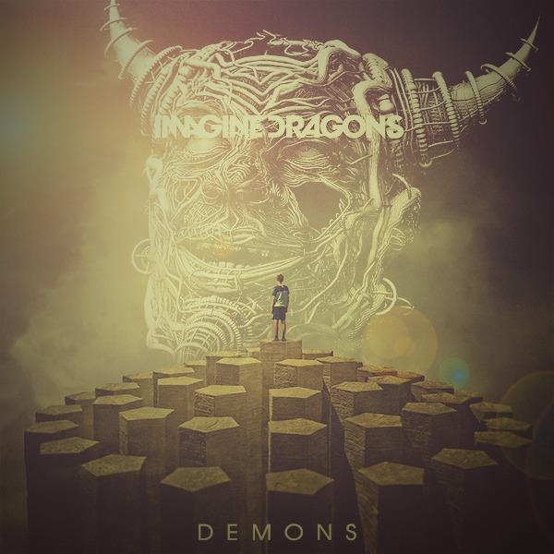
http://www.bing.com/images/search?q=imagine+dragons+demons&FORM=HDRSC2#view=detail&id=8C456BC33D65DC4EACC1E134925349BB945F93A0&selectedIndex=13

