O Captain, My Captain!
Walt Whitman

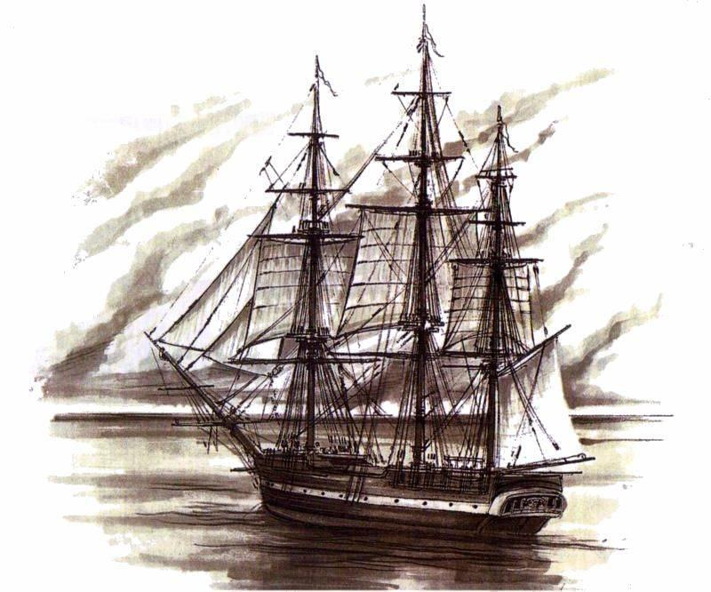
1 O Captain! my Captain! our fearful trip is done,
2 The ship has weather'd every rack, the prize we sought is won,
3 The port is near, the bells I hear, the people all exulting,
4 While follow eyes the steady keel, the vessel grim and daring;
5 But O heart! heart! heart!
6 O the bleeding drops of red,
7 Where on the deck the Captain lies,
8 Fallen cold and dead.
9 O Captain! my Captain! rise up and hear the bells;
10 Rise up --- for you the flag is flung --- for you the bugle trills,
11 For you the bouquets and ribbon'd wreaths --- for you the shores a-crowding,
12 For you they call, the swaying mass, their eager faces turning,
13 Here Captain! dear father!
14 The arm beneath your head!
15 It is some dream that on the deck,
16 You've fallen cold and dead.
17 My Captain does not answer, his lips are pale and still,
18 My father does not feel my arm, he has no pulse nor will,
19 The ship is anchor'd safe and sound, its voyage closed and done,
20 From fearful trip the victor ship comes in with object won;
21 Exult O shores, and ring O bells!
22 But I with mournful tread,
23 Walk the deck my Captain lies,
24 Fallen cold and dead.

WARM UP

Reread “O Captain, My Captain!” by Walt Whitman and determine whether each of the following statements is (DS) directly stated or an (I). If it is directly stated, identify the line number(s) in which it is referenced.

- The captain is dead.
- The captain is the speaker’s father.
- The ship is close to land.
- The crew was on a scary voyage.
- This ship won the prize it sought.

DID YOU KNOW…Walt Whitman wrote the poem after Abraham Lincoln's assassination. Repeated metaphorical reference is made to this issue throughoutthe verse. The "ship" spoken of is intended to represent the United States of America, while its "fearful trip" recalls the troubles of the American Civil War. The title character "Captain" is Lincoln himself.

