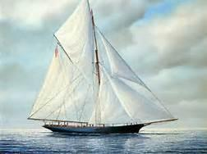
“O Captain, My Captain” Essay Organizer
Does Walt Whitman’s use of extended metaphor accurately portray the sense of loss felt by Americans after Abraham Lincoln’s assassination? Be sure to use evidence from the texts that supports the viewpoints of Americans at that time. Use the graphic organizer below to complete your thoughts.

Walt Whitman’s “O Captain, my Captain!”

Extended Metaphor | Meaning
Supporting Metaphor Details | Meaning

North/South Reaction to Assassination

 | Metaphor | Opinion | Direct Quote | Direct Quote
“When the Bells Tolled
For Lincoln”

“Northerner’s Reaction
To Lincoln’s Assissination”

