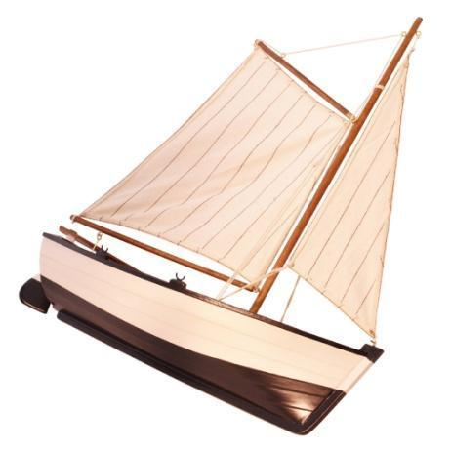

“O Captain, My Captain” Essay Organizer

Does Walt Whitman’s use of extended metaphor accurately portray the sense of loss felt by Americans after Abraham Lincoln’s assassination? Be sure to use evidence from the text to support the Northerner’s opinion. Use the graphic organizer below to complete your thoughts.

Walt Whitman’s “O Captain, my Captain!”

Extended Metaphor | Meaning
Supporting Metaphor Details | Meaning

North Reaction to Assassination

 | Opinion | Direct Quote
“The Civil War Ends: A Small Town’s Reaction””

