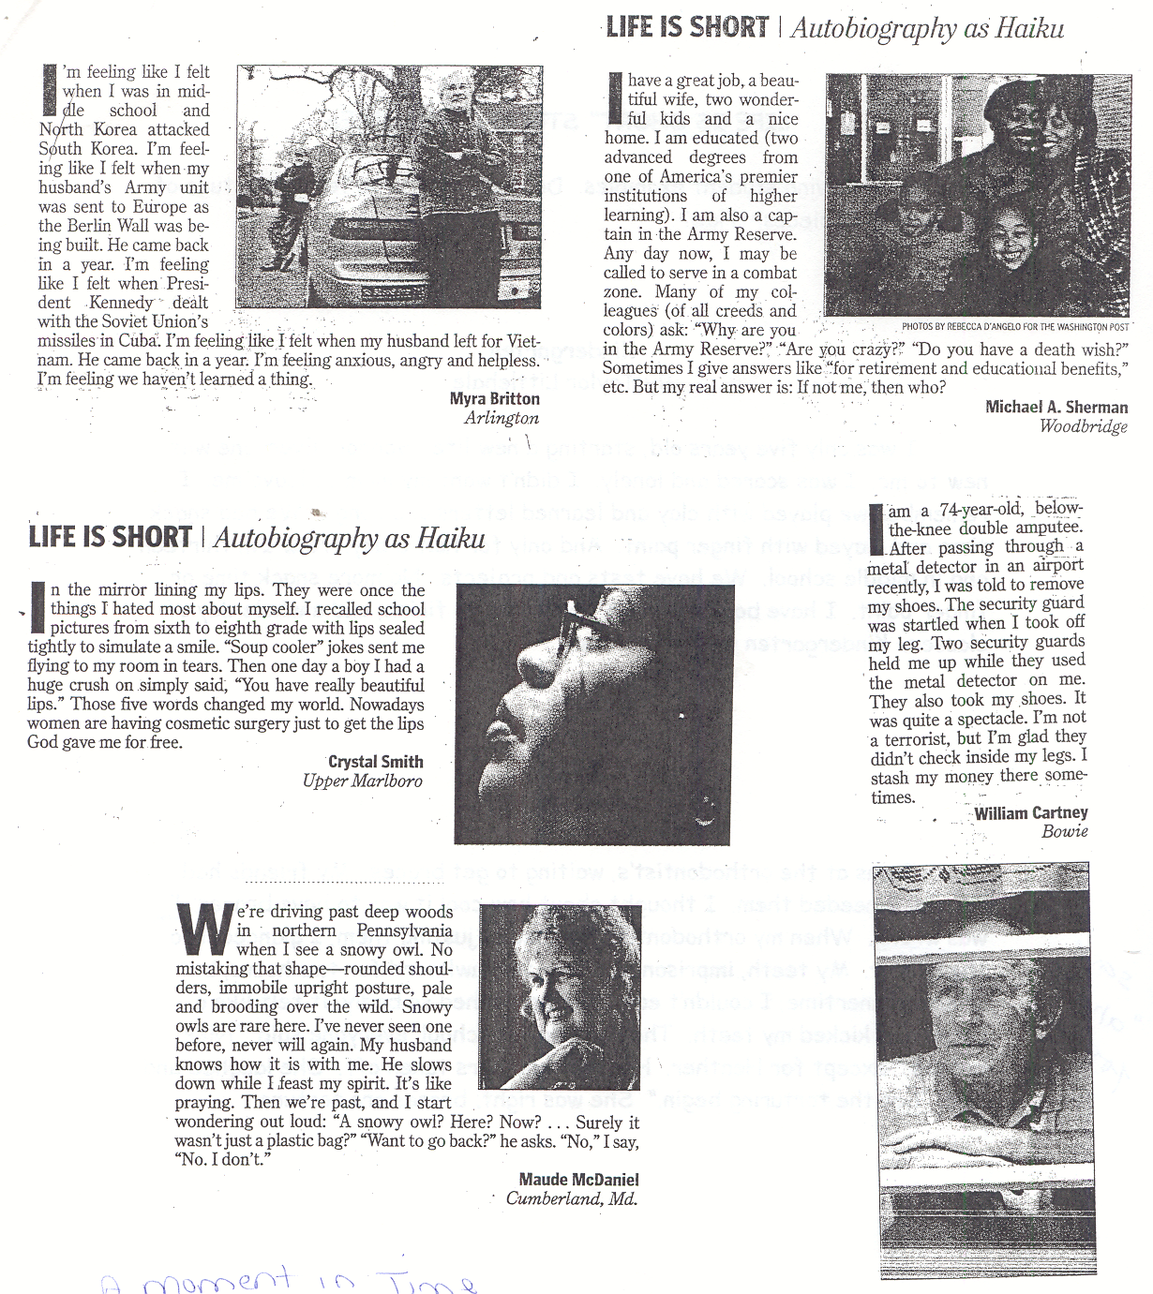

“A Moment in Time” Student Examples

Read the following student examples. Do they match the text structure of the published pieces? How?

Kindergarten
by Taylor Littlehale

I was only five years old, starting a new life. School. Everyone was new to me. I was scared and lonely. I didn't want my mom to leave me. I remember we played with clay and learned letters and songs. We had snack time and played with finger paint. And only for half a day. Now I'm thirteen and in middle school. We have tests and projects. No more snack time or finger paint. I have books to read, homework to finish, and a whole day of classes. Kindergarten wasn't that bad.

- Does this narrative match the text structure of the published pieces?

- How?

Braces
by Christiane Tran

I was at the orthodontist's, waiting to get braces. My friends had braces; I needed them. I thought about how cool it was to have braces; I was wrong. When my orthodontist finished adjusting them, I glanced into the mirror. My teeth, imprisoned. They felt awkward for two hours, but around dinnertime, I couldn't eat. The pain ached so badly, it felt like a horse had kicked my teeth. The next day at school, everyone said, "Nice braces," except for Heather. Heather had hers taken off. She laughed and said, "Let the torturing begin." She was right; braces are torture.

- Does this narrative match the text structure of the published pieces?

- How?

In Collecting Your Writing Territories, Consider…

memories: early, earlier, and recent

obsessions

idiosyncrasies

problems

dreams

itches

understandings

confusions

passions

sorrows

risks

accomplishments

fears

worries

fantasies

family, close and distant

friends, now and then

fads

favorites, now and then

pets, now and then

teachers, now and then

places: school, camp, trips, times away with friends and relatives

hobbies

sports

games

music

books

poems

songs

movies

writers and artists

food

pet peeves

beloved things—objects and possessions—now and then

all the loves of your life

IF YOU LOSE YOUR PEN
Ruth Forman
and all you find is a broken pencil on the floor
and the pencil has no sharpener
and the sharpener is in the store
and your pocket has no money
and if you look again
and all you find is a black Bic
and the Bic you need is green
and if it appears beneath the mattress of your couch
but the couch is dirty and suddenly you want to clean
beneath the pillows
but you have no vacuum and the vacuum is in the store
and your pocket has no money
it is not your pen you are looking for
it is your tongue and those who speak with it
your grandmothers and doves and ebony spiders
hovering in the corners of your throat
it is your tongue
and if you cannot find your tongue
do not go looking for the cat
you know you will not find her
she is in the neighbor's kitchen eating Friskies
if you cannot find your tongue do not look for it
for you are so busy looking it cannot find you
the doves are getting dizzy and your grandmothers annoyed
be still and let them find you
they will come when they are ready
and when they are
it will not matter if your pockets are empty
if you write with a green Bic or a black Bic
or the blood of your finger
you will write
you will write

