Letter from Vincent Van Gogh to Theo Van Gogh
8 September 1888

My dear Theo,

Thank you a thousand times for your kind letter and the 300 francs it contained; after some worrying weeks I have just had a much better one. And just as worries do not come singly, neither do the joys. For just because I am always bowed down under this difficulty of paying my landlord, I made up my mind to take it gaily. I swore at the said landlord, who after all isn't a bad fellow, and told him that to revenge myself for paying him so much money for nothing, I would paint the whole of his rotten shanty so as to repay myself. Then to the great joy of the landlord, of the postman whom I had already painted, of the visiting night prowlers, and of myself, for three nights running I sat up to paint and went to bed during the day. I often think that the night is more alive and more richly coloured than the day.

Now, as for getting back the money I have paid to the landlord by my painting, I do not dwell on that, for the picture is one of the ugliest I have done. It is the equivalent, though different, of the “ Potato Eaters.”

I have tried to express the terrible passions of humanity by means of red and green.

The room is blood red and dark yellow with a green billiard table in the middle; there are four lemon-yellow lamps with a glow of orange and green. Everywhere there is a clash and contrast of the most alien reds and greens, in the figures of little sleeping hooligans, in the empty dreary room, in violet and blue. The blood-red and the yellow-green of the billiard table, for instance, contrast with the soft tender Louis XV green of the counter, on which there is a rose nosegay. The white clothes of the landlord, watchful in a corner of that furnace, turn lemon-yellow, or pale luminous green.

I am making a drawing of it with the tones in watercolour to send to you tomorrow, to give you some idea of it.

I wrote this week to Gauguin and Bernard, but I did not talk about anything but pictures, just so as not to quarrel when there is probably nothing to quarrel about.

But whether Gauguin comes or not, if I were to get some furniture, henceforth I should have, whether in a good spot or a bad one is another matter, a pied à terre, a home of my own, which frees the mind from the dismalness of finding oneself in the streets. That is nothing when you are an adventurer of twenty, but it is bad when you have turned thirty-five.

Today in the Intransigeant I noticed the suicide of M. Bing Levy. It can't be the Levy, Bing's manager, can it? I think it must be someone else.

I am greatly pleased that Pissarro thought something of the “Young Girl.” Did Pissarro say anything about the “Sower”? Afterwards, when I have gone further in these experiments, the “Sower” will still be the first attempt in that style. The “Night Café” carries on from the “Sower,” and so also do the head of the old peasant and of the poet, if I manage to do this latter picture.

It is colour not locally true from the point of view of the trompe d'oeil realist, but colour to suggest some emotion of an ardent temperament.

When Paul Mantz saw at the exhibition the violent and inspired sketch by Delacroix that we saw at the Champs Elysées - the “Bark of Christ” - he turned away from it, exclaiming in his article: “I did not know that one could be so terrible with a little blue and green.”

Hokusai wrings the same cry from you, but he does it by his line, his drawing; as you say in your letter - “the waves are claws and the ship is caught in them, you feel it.”

Well, if you make the colour exact or the drawing exact, it won't give you sensations like that.

Anyhow, very soon, tomorrow or next day, I will write to you again about this and answer your letter, and send you the sketch of the “Night Café.”

Tasset's parcel has arrived. I will write tomorrow on this question of the coarse grained colour. Milliet is coming to see you and pay his respects to you one of these days, he writes to me that he is coming back.

Thank you again for the money you sent. If I went first to look for another place, would it not very likely mean fresh expense, equal at least to the expense of a removal? And then should I find anything better all at once? I am so very glad to be able to do the furnishing, and it can't but help me on. Many thanks then, and a good handshake, till tomorrow.

Yours,
Vincent

Related Paintings

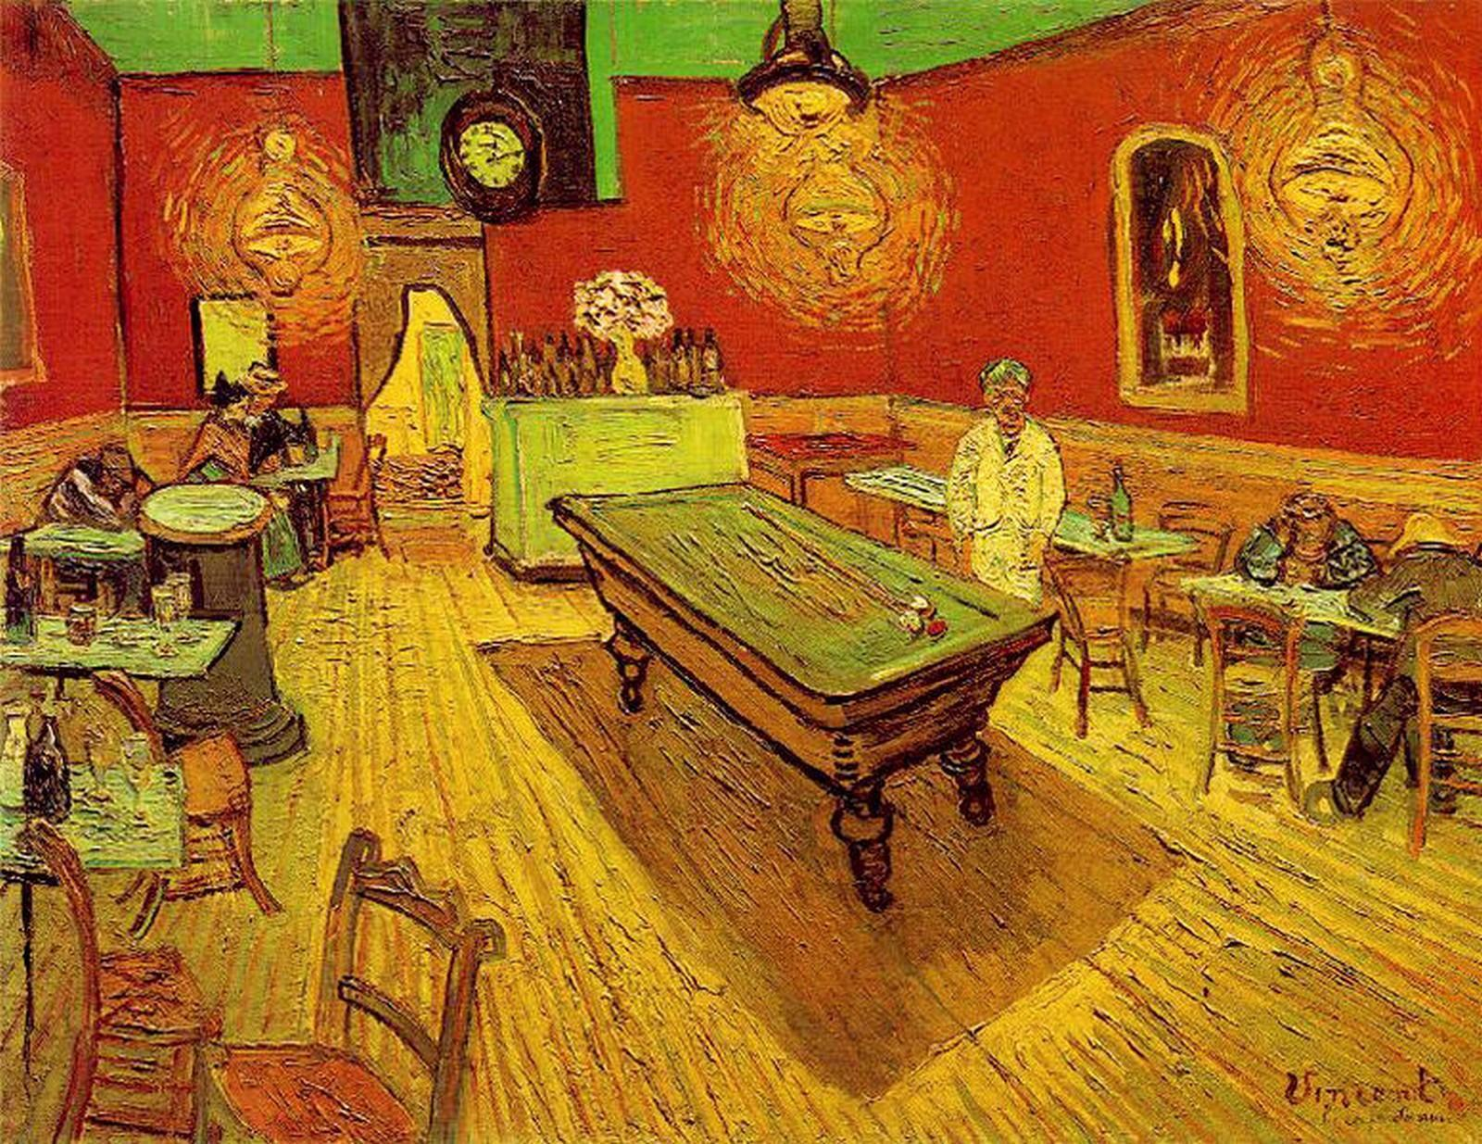  "Night Cafe on Place Lamartine in Arles," Vincent van Gogh | 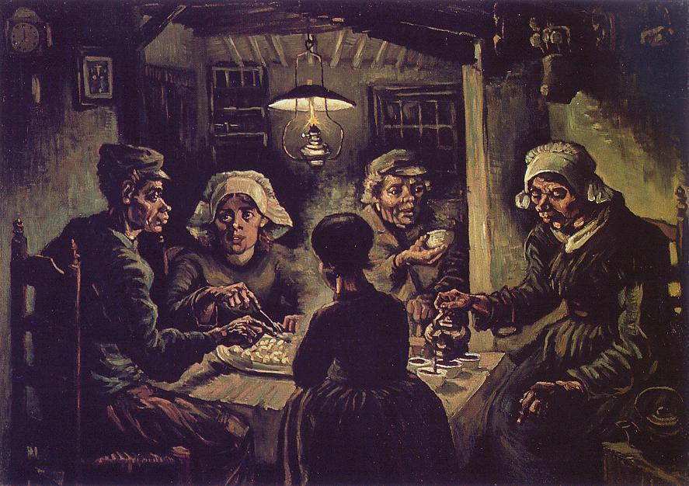  "Potato Eaters,"  Vincent van Gogh | 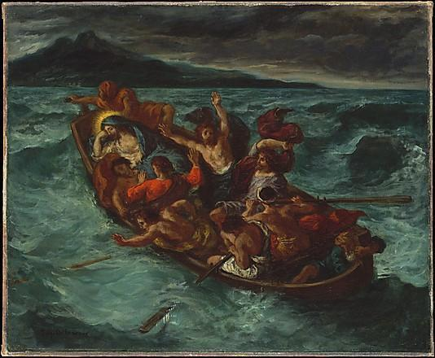  "Christ on the Sea of Galilee," Delacroix

