Informational Essay Format

Introductory Paragraph
The purpose of the introductory paragraph is to (1) capture your audience’s attention, (2) briefly summarize Van Gogh’s life, (3) and present the question that your essay aims to answer. You must refer to at least four of the six texts that we read/viewed in order to answer your question. You will be synthesizing the texts that we encountered during our study of Van Gogh and will draw conclusions that answer the question you created.

Possible Ways to Capture Audience’s Attention
- Cite a Quote
- Share an Startling Fact or Statistic
- Ask a Rhetorical Question
- Share an Anecdote

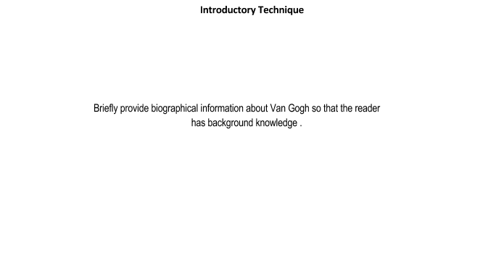

Introduce the question that you intend to answer with your research.

