Name__________________________________
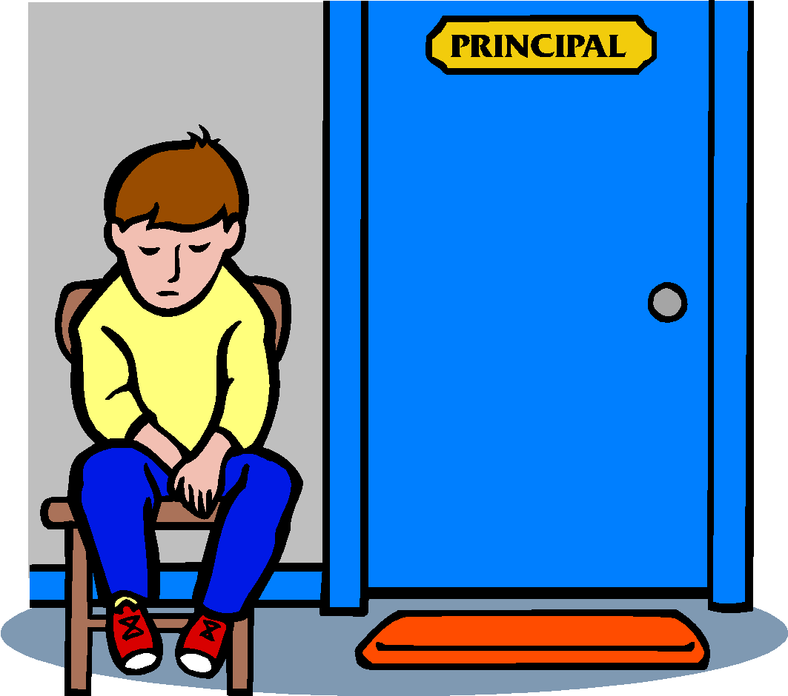
“Charles”
By Shirley Jackson
Literature pg. 336
Vocabulary:

- Cynically-_______________________________________________________

- Deprived-_______________________________________________________

- Haggard-_______________________________________________________

- Insolently-______________________________________________________

- Raucous-________________________________________________________

- Renounced-______________________________________________________

- Simultaneously-__________________________________________________

- Wary-_________________________________________________________

Beginning the Story:

- Describe the change in Laurie’s clothing on the day he starts school. Draw a conclusion about how this change signals a shift in Laurie’s behavior.

- What does Laurie say about Charles’ behavior on the first day of school? What expression is on his face as he tells his father about his day?

Continuing the Story:
- Charles continues to cause trouble in the classroom. On the chart below, list the additional things he does during the first week of school. List the things the teacher does to try to change his behavior.

Things that Charles does | Things the teacher does
Tues.

Weds.

Thurs.

Fri.

- Why is Laurie’s mother upset when she has to miss the first PTA meeting?

- What does the teacher do with Charles during the third and fourth weeks and how does his behavior change?

- What does Laurie’s mother learn when she mentions Charles to the teacher?

Making Inferences:
Choose one of the two questions below to answer. Remember to use the RACE strategy.
- What can the reader infer about the changes in Laurie’s behavior? Use details from the text to support your inference(s).
- What inference(s) can the reader make about Laurie’s teacher? Use details from the text to support your inference(s).

