Name________________________________

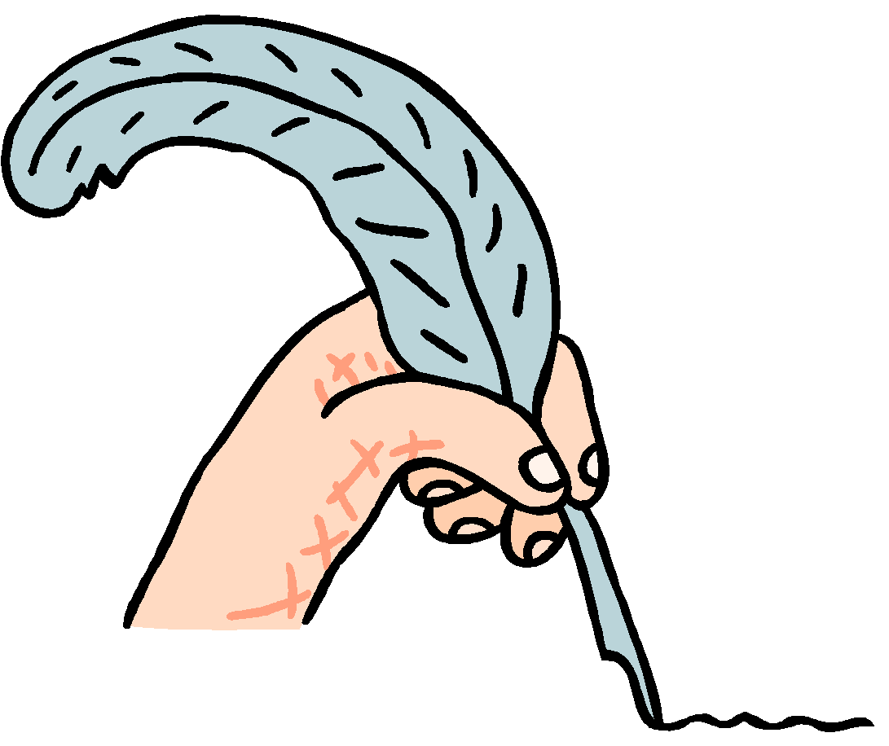
Acrostic Poem Spec Sheet
Check that you have:
- created a title that is related to your theme;
~Do not underline or put your title in quotation marks.
~Do capitalize the first word and other important words in the title.
~Your title must follow the Good Title guidelines.

- made sure that your name stands out on the page;

- included at least;
Ten Nouns
Five Verbs
Ten Adj.
Four Adverbs
Four Prep.
One Intj.
One Pronoun
Two Conj.

- improved your word choice by using a thesaurus;
ORIGINAL WORD | IMPROVED WORD

- word-processed or written the final draft in pen. NO pencil!!

- included a picture or symbol of your theme.

Construct Measured | Score Point 4 | Score Point 3 | Score Point 2 | Score Point 1 | Score Point 0
Development of Ideas | The student response addresses the prompt and provides effective and comprehensive development of the topic by using numerous details and description; the development is consistently appropriate to the task, purpose, and audience. | The student response addresses the prompt and provides effective development of the topic by using sufficient details and description; the development is largely appropriate to the task, purpose, and audience. | The student response addresses the prompt and provides some development of the topic by using some details and description; the development is somewhat appropriate to the task, purpose, and audience. | The student response addresses the prompt and provides minimal development of the topic by using limited details and description; the development is limited in its appropriateness to the task, purpose, and/or audience. | The student response is underdeveloped and therefore inappropriate to the task, purpose, and/or audience. | Writing Score  Comments:
Organization | The student response demonstrates a logical, well-executed progression of ideas, making it easy to follow the progression of the poem. There is a thought-provoking Good Title and a picture to represent the poem. The final draft is neatly presented without pencil. | The student response demonstrates a logical progression of ideas, making it fairly easy to follow the progression of the poem. There is a Good Title and a picture to represent the poem. The final draft is neatly presented without pencil. | The student response demonstrates some logic in the progression of ideas. These ideas are usually discernible but not obvious in the poem. This is a Good Title and picture to represent the poem. The final draft looks satisfactory. | The student response demonstrates limited coherence in the progression of ideas making the poem somewhat unclear. This is a weak Good Title and picture to represent the poem. The final draft is messy and/or uses pencil. | The student response demonstrates a lack of coherence in the progression of ideas making the poem very unclear. There is no Good Title and picture to represent the poem. The final draft is unsatisfactory.
LANGUAGE
Construct Measured | Score Point 4 | Score Point 3 | Score Point 2 | Score Point 1 | Score Point 0
Clarity of Language | The response uses precise language* consistently, including descriptive words and phrases, sensory details, linking and transitional words, words to indicate tone, and/or domain-specific vocabulary. The poem contains all parts of speech required correctly and thoroughly. | The response uses mostly precise language*, including descriptive words and phrases, sensory details, linking and transitional words, words to indicate tone, and/or domain-specific vocabulary. The poem contains all parts of speech required mostly correct. | The response uses some precise language*, including descriptive words and phrases, sensory details, linking and transitional words, words to indicate tone and/or domain-specific vocabulary. The poem contains all parts of speech required somewhat correctly. | The response includes limited descriptions, sensory details, linking or transitional words, words to indicate tone, or domain-specific vocabulary. The poem contains most of the parts of speech required, but they are inappropriately used. | The student writing shows little to no awareness of the norms of the discipline. The response includes little to no precise language. The poem contains few/no parts of speech required and are always inappropriately used. | Language Score  Comments:

